TEAM CAPTAIN INSTRUCTIONS

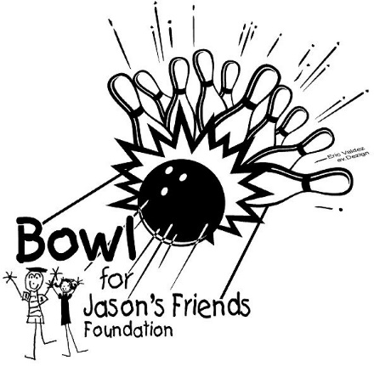
Thank you for volunteering to be a Team Captain in this year’s Bowl for Jason’s Friends fundraiser. Your participation will help families in our community and throughout Wyoming whose children are battling childhood cancers and brain or spinal cord tumors.

Each fundraising team will consist of five members with one designated as Team Captain. Your team may bowl as many games as possible in about an hour and a half at Camelanes on Saturday, March 7, 2026. Your team will be assigned a bowling time upon registration.

Bowler benefits:
- Free bowling and shoe rental
- Free food for all participants
- Free t-shirt to every bowler that collects $100 or more
in donations
- Drawings

TEAM CAPTAIN RESPONSIBILITIES:

- RECRUIT a fundraising team of five bowlers, including you. A team may represent an organization, business, school, friends, family, etc. Age or bowling ability does not matter. You may put together several teams of five with a designated Team Captain for each team.

- REGISTER YOUR FUNDRAISING TEAM for one of the two time slots available to bowl – 3:00PM and 5:00 PM. Register early to ensure your first choice of bowling time.

  - REGISTER ONLINE at jasonsfriends.org/bowl

  - REGISTER BY PHONE by calling Jason’s Friends at (307) 235-3421

UTILIZE THE BOWL FOR JASON’S FRIENDS PERSONAL FUNDRAISING PAGE!
https://secure.qgiv.com/event/4thannualbowlforjasonsfriends/

After you register your team for a bowling time, you will receive a confirmation email with a link to access our personal fundraising pages where you and your teammates can receive online donations from your supporters! Each team member will need to set-up their own personal page if they choose to online fundraise. It is easy to use and allows your team to make personal appeals to friends and family through email, Facebook, and other social media, as well as track progress toward fundraising goals individually. Your supporters will be able to go to your personal link and give directly to you.

- DISTRIBUTE the Donation Envelopes to your teammates or direct them to jasonsfriends.org/bowl to print the DONATION SHEET. Point out the prizes available to win for most donations collected. Ask your team to start collecting donations immediately! Each teammate needs to collect at least $100 in donations to help meet our fundraising goals, earn a FREE t-shirt, and be entered into a drawing for the opportunity to win prizes! The more they collect the more chances they have to win!

- COLLECT ALL donations prior to bowling. There will be no billing to collect donations after the event.

- BOWL at your reserved time on Saturday, March 7, 2026. Please have your team arrive 15 minutes before your scheduled time and check-in at the Registration Table. Have each bowler bring their completed Donation Envelope or Donation Sheet stapled to an envelope showing their contact details, total of their online gifts plus amounts of each cash/check donation. Place all money collected in the envelope.

Questions? Visit jasonsfriends.org, call Jason’s Friends Foundation at (307) 235-3421 or email info@jasonsfriends.org

