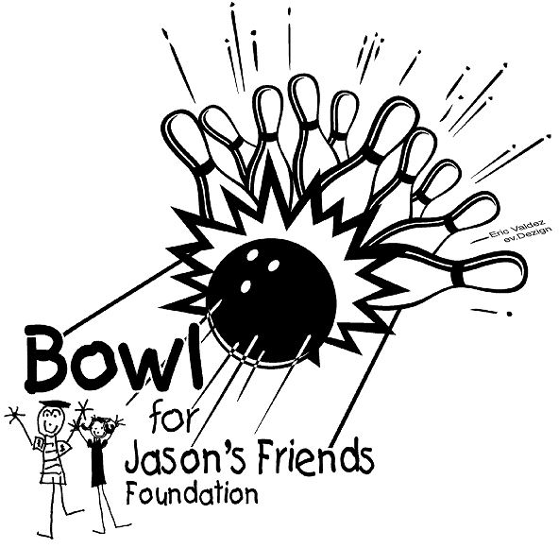

TIP SHEET FOR FUNDRAISING TEAMS

REMEMBER THE CAUSE
You are asking sponsors to donate to Jason’s Friends Foundation. Your request is on behalf of those families in our community and throughout Wyoming whose children are battling childhood cancers and brain or spinal cord tumors.

Jason’s Friends Foundation is a non-profit 501(c)(3) corporation.
Our funding comes from grants, private donations, and fundraisers. Nearly 90% of the dollars we take in go directly to the families we help.

BE INFORMED AS TO HOW WE DID ON LAST YEAR’S FUNDRAISER
The 28th Annual Bowl for Jason’s Friends event will help families in our community and throughout Wyoming whose children are battling childhood cancers and brain or spinal cord tumors. Last year the proceeds totaled over $400,000 with almost 800+ bowlers participating. This will be the only fundraiser we have in 2026. We are hoping for a large turnout and strong support from the Casper and Gillette communities as well as the entire state to surpass our goal of $375,000! Remind donors that they can learn more about Jason’s Friends at jasonsfriends.org.

MAKE A LIST OF POTENTIAL DONORS Here are some possibilities:
email contacts mechanics plumbers florists
Facebook friends landlords relatives pharmacists
insurance agents CPAs bankers teachers
secretaries attorneys brokers neighbors
employers beauticians realtors policemen
dentists jewelers electricians coworkers friends classmates doctors veterinarians

KEEP YOUR DONATION SHEET HANDY
Over the next few weeks, you will see plenty of potential donors. It is easy to fill the sheet out if you remember to ask for their support. PLEASE BE SURE TO FILL OUT THE DONOR CONTACT INFORMATION ON THE SHEET COMPLETELY TO ALLOW JASON’S FRIENDS FOUNDATION TO SEND A THANK YOU AND A RECEIPT.


UTILIZE THE BOWL FOR JASON’S FRIENDS PAGE
Set-up your own personal fundraising page by visiting https://secure.qgiv.com/event/28thannualbowlforjasonsfriends/ to collect donations online. It is easy to use and allows you to make personal appeals to friends and family through email, Facebook and other social media, as well as track progress toward fundraising goals. Your supporters will be able to go to your personal link and give directly to you.

PLEASE COLLECT ALL DONATIONS PRIOR TO BOWLING
If you don’t run into potential donors in person, call them on the phone. You can fill in their name and donation with their approval. Just remember to collect the donations before the fundraiser. There will be no billing to collect donations after the event. DONOR’S GIFTS ARE TAX DEDUCTIBLE AND A RECEIPT WILL BE MAILED TO THEM IF WE HAVE THEIR CONTACT INFORMATION.

THANK YOU FOR COLLECTING DONATIONS TO HELP JASON’S FRIENDS FAMILIES. WE CAN’T WAIT TO CELEBRATE WITH YOU ON FEBRUARY 28, 2026!

